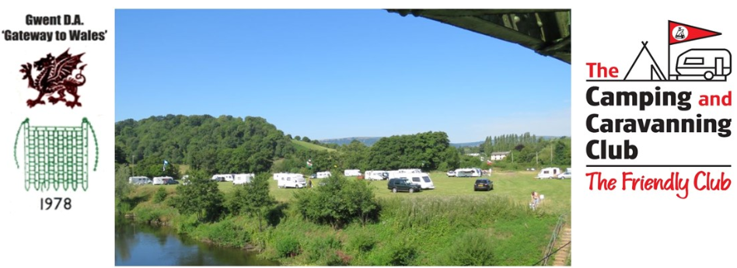

Please complete in full and return as soon as possible to the address below. All confirmations will be sent by email. A separate booking form is required for each unit & meet.
Gwent DA Booking Form: Blackmore Club site
Meet date: 14 March 2024
Membership number: |  |  | DA:
Number of adult members  (18 and over): |  |  |  | Number of Children under 18:
Contact Details:
Name:
Address:
Telephone: |  |  |  |  |  | Vehicle Reg
Email:
Unit type/size: (please circle) | Caravan |  | Motorhome |  |  |  | Trailer Tent | Tent |  | Unit size
Special Requirements (if any):

Date of arrival |  |  |  |  | Date of departure
Pitch fee pun: £ |  |  |  |  | No of nights:
Total fee: |  |  |  |  | £
Less non-refundable deposit if applicable: |  |  |  |  | £
Fee due on arrival, if applicable: |  |  |  |  | £
Cheques payable to: Gwent DA
Booking form and deposit to be sent to:
Ann Pleas, 42 Pentre Close, Cwmbran, Newport, NP44 7LR

Payment can also be made via bank transfer to:
Acc No: 00522303 Sort Code: 30-96-00
Ref: last name & BM

Official use only
Deposit
Date bkd/pd

All enquires/queries to sites officer: gwentda1978@gmail.com Confirmations via email/mobile text.

